### SNACK CRATE SUBSCRIPTION HANDLING SYSTEM

Snack Crate is an online company that travels the world to find the most interesting snacks and deliver them to your door. Each month features new and exciting places from around the globe. Snack Crate has a department dedicated to handling non-digital subscriptions. When a subscriber submits a subscription request through the mail, the subscription clerk verifies the subscription request to ensure that all the necessary information has been included and that the correct payment amount has been enclosed (certified cheque).

Once the subscription request is verified as correct and complete, the subscription clerk forwards the payment to the Finance department, checks the Special Offer file to check that any special offers associated with the subscription request [i.e. free pineapple cakes] and applies the special offer if applicable, and files the original subscription request.

Once this is completed, the subscription clerk then inputs the subscriber information that appears on the subscription request form, into the Subscriber file. If the subscriber is a repeat subscriber, the clerk verifies and updates the subscriber information. At the end of each day, the subscription clerk prepares mailing labels for that day’s processed subscription requests and sends these labels to the Production department.

Each day, the subscription clerk prepares a three-part Special Offer Requisition form for any subscription request with special offer item[s] to be sent to the subscriber. The subscription clerk sends this form to the Shipping department for processing.

If the subscription request is incomplete or incorrect, the subscription clerk contacts the subscriber. If the subscriber cannot be contacted immediately, the subscription clerk files these incomplete requests with a status of “Incomplete”. When the subscriber provides the needed information, the subscription clerk enters this information onto the original subscription request form, and then processes the subscription request using existing procedures.



**Required:**

**UML**

1. Create the Use Case Narratives
2. Draw the Sequence Diagram for each Use Case
3. Draw the Class Diagram

### Entity Relationship Diagram

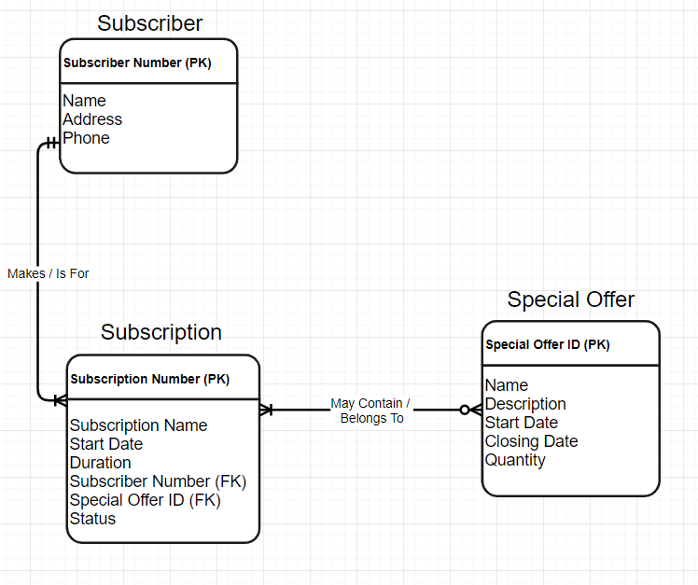

### Use Case Diagram

